Booster Club
Lion Players Theatre Company

Lion Players Theatre Company or LPTC is the theatre department of Spring High School. LPTC produces four to six productions per year in both the 830-seat Auditorium and 200-seat Black Box Theater. We also teach a full curriculum of theatre and technical theatre courses.

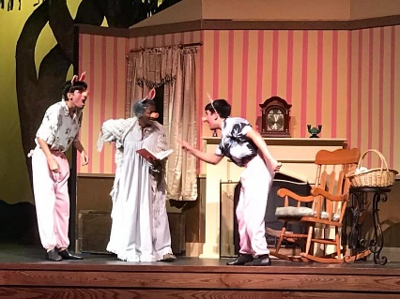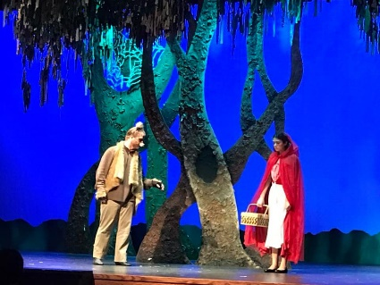
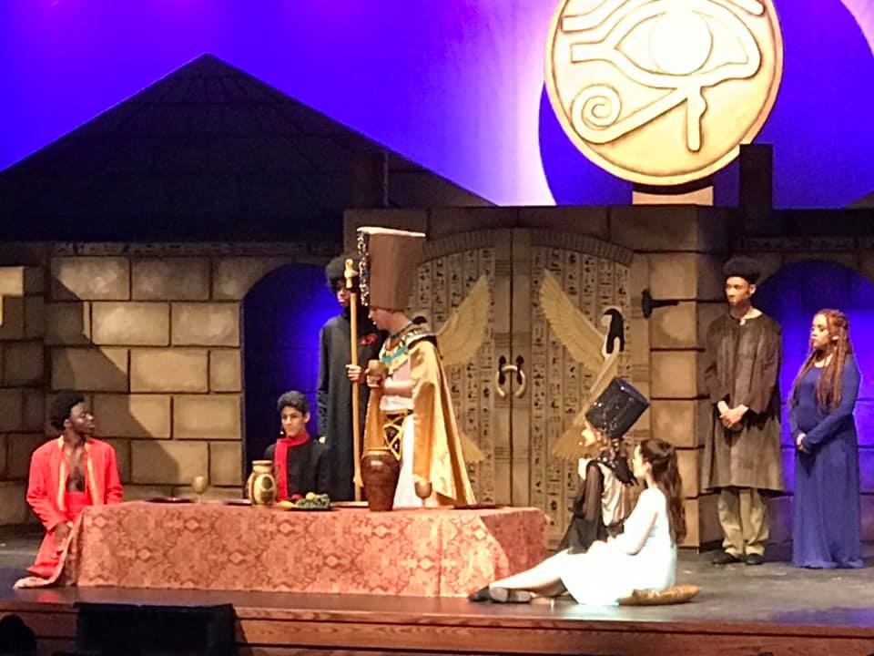
Supporting LPTC is an investment in a track record of success.

LPTC is a highly-awarded High School Theatre group dedicated to providing a full curriculum of courses and performance opportunities to students.

LPTC has had numerous State and National Thespian qualifiers.

LPTC has qualified for District & Bi-District for the last two years.

LPTC has garnered numerous Tommy Tune Award nominations and won Best Set Design & Best Lighting for Aida.

LPTC is committed to providing a university preparatory experience for our students.

Your patron donation creates these opportunities for the students.

Help our students learn, grow, stretch their boundaries, all while having fun!

For each major production, in addition to providing on stage acting opportunities, students have hands-on opportunities to learn:
- Set design, construction, and dressing
- Lighting and sound
- Props and scenery
- Design and creation of costumes
- Script and character analysis
- Publicity campaigns and more…

Theatre students are provided with the opportunity to compete and showcase their work at the State and National Thespian Conventions.

Theatre students have the opportunity to prepare portfolios of their work to use in interviewing and college placement.

Theatre students who want to major in theatre have the opportunity to audition for university placement and scholarships during the year.

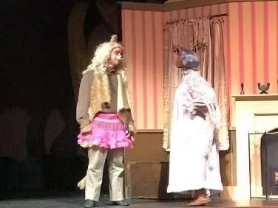

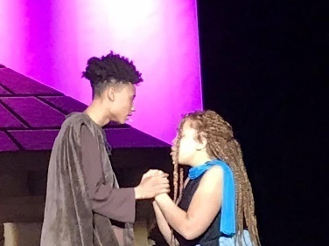

Thank you for your support of Lion Players Theatre Company. Your tax-deductible donation provides opportunities for students
that they would not otherwise have!

19428 I-45N, Spring, TX 77373
www.lionplayerstheatrecompany.com
Lion Players Theatre Company
Patron Program Information

Platinum Sponsorship: $1,000.00+
  - Name in all programs as a Platinum Sponsor
  - Passes valid for twelve tickets to LPTC production(s)
  - 8 x 10 Plaque of Appreciation reflecting Platinum Sponsorship
  - One full page ad in all LPTCprograms
  - Name displayed in Lobby as a Platinum Sponsor
  - Priority seating for performances(Must be reserved at box office inadvance)

Diamond Sponsorship: $500.00-999.00
  - Name in all programs as a Diamond Sponsor
  - Passes valid for eight tickets to LPTC production(s)
  - Priority seating for performances (Must be reserved in person at box office in advance)
  - 5 x 7 Plaque of Appreciation reflecting Diamond Sponsorship
  - One half page ad in all LPTC programs
  - Name displayed in Lobby as a Diamond Sponsor

GoldSponsorship: $250.00-499.00
  - Name in all programs as a Gold Sponsor
  - Passes valid for six tickets to LPTC production(s)
  - Display sign for your business
  - One quarter page ad in all LPTC programs
  - Name displayed in Lobby as a Gold Sponsor

SilverSponsorship: $125.00-249.00
  - Name in all programs as a Silver Sponsor
  - Pass valid for four tickets to LPTC production(s)
  - Display sign for your business
  - Name displayed in Lobby as a Silver Sponsor all season

CopperSponsorship: $50.00-124.00
  - Name in all programs as a Copper Sponsor
  - Pass valid for two tickets to LPTC production(s)
  - Display sign for your business
  - Name displayed in Lobby as a Copper Sponsor

PatronSponsorship: $25.00-49.00
  - Name in all programs as a Patron Sponsor
  - Display sign for your business
  - Name displayed in Lobby as a Patron Sponsor

All Contributions are tax-deductible.
LPTC Booster Club is a 501(c)3 non-profit, tax-exempt organization

Lion Players Theatre Company
Due Date:
December 31st
To ensure your name/ad is in the playbill.
You may of course donate after thisdate for additional productions.
Patron Program Information
2021-2022
PATRON NAME - as it will appear in program and lobby display: (Please print legibly)

CONTACT INFORMATION
Contact Name | Street Address | City/State | Zip Code

Telephone | Fax | E-Mail Address

Please Circle One: Are you a: Parent (Student name: ) Alumni, Business or Community Member?

LEVEL OF CONTRIBUTION: (Check One)

Benefactor  ($2000+) | Platinum  ($1000-$1999) | Diamond  ($500-$999) | Gold  ($250-$499) | Silver  ($125-$249) | Copper  ($50-$124) | Patron  ($25-$49)

Total Contribution:$
Will your company be matching your donation?(CircleOne) No Yes
All matching funds upon receipt are credited to the total contribution of the Patron Family.

(Company)

Please check here if you prefer not to receive a plaque for your donation (Money from plaque will be donated directly back to student materials for LPTC)

Program Advertisements:
Please see attached guidelines for program advertisements, which are available for donors contributing at the Gold, Diamond and Platinum levels

Ad attached: (Circle One) Yes/No or Email to LPTCProgramAds@gmail.com by October 8, 2021.

Contact PersonforAdvertisement: E-Mailaddress: Phone:
AmountEnclosed:$ Check No: (Please do not enclose cash- Make checks payable to: LPTC Booster Club)

Or Pay with Cash App, PayPal, or Zelle (add 3% convenience fee) Search: LPTC Boosters or LPTCBoosterclub@gmail.com

Mail to:
Lion Players Theatre Company
Marilyn Ocker, Director
19428 I-45N, Spring, TX 77373

LPTC Boosters are a 501(c)3 non-profit, tax exempt organization

Lion Players Theatre Company

Full Page
Platinum Level $1,000+

7.5 in
(4.625 pixels)

4.625 in
(333 pixels)
3.75 in (270pixels)
½ Page
Diamond $500-$999
¼ Page Vertical
4.625 in
(333 pixels)
3.75 in (270pixels)
¼ Page Horizontal
1.875 in
(135 pixels)
4.625 in
(333 pixels)
¼ Page
Gold $250-$499
2.3125 in
(166.5 pixels)
Program Patron Ad Specs

Ads must be submitted in a jpg format with a resolution of 150 dpi or higher.
Please submit all ads via email to LPTCProgramAds@gmail.com

