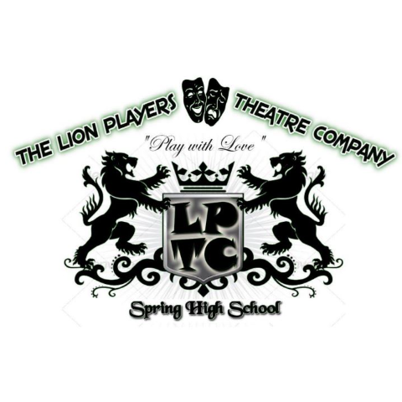

**Lion Players Theatre Company**

**“Spotlight” Ad**

Actors, actresses, techies, officers, stage managers,volunteers, auditioning for one show or five… all members of this wonderful Company deserve a **“Spotlight”** in this year’s program. Recognize your special Lion Players Theatre Company Member with a **“Spotlight” Ad**. It’s easy! Just submit your favorite photo and text, and we’ll do the rest. The ad will appear in every program so **hurry and get yours in. “Spotlight” Ads are being sold for a limited time only.**



**“Spotlight” Ad Rates:**

*Quarter Page (2.3” x 3.8”)* $25

*Half Page (5” x 3.8”)* $50

*Full Page (5” x 8”)* $75

**Here’s how to submit an ad:**

1. Include your ad size and message in an email. Attach the photo in high resolution jpg format. **If you ad text, be sure to save your jpg and text as a PDF**. Email the completed PDF file to [LPTCProgramAds@gmail.com](mailto:LPTCProgramAds@gmail.com)
2. Mail payment and this form to:

Spring Lion Players Theatre Booster Club

Attn: Program Ad Sales

19428 I-45 North

Spring, TX 77373

PLEASE PAY WITH:

Cash (please do not mail cash) Check # Payable to LPTC Booster Club

Cash App, Zelle, or PayPal (Circle App and please include a 3% convenience fee)

*Thank you for supporting the fine arts and Spring Lions Players Theatre Department.*

Name of Company Member:

Your Name:

Address:

Phone: Email:

Circle the size of your ad: ¼ Page ½ Page Full Page

Office Use Only Date Rec’d Cash Rec’d Chk Rec’d Receipt#

**“Spotlight” Ads are Due by Friday, October 8, 2021, to be included in the current program publication.**