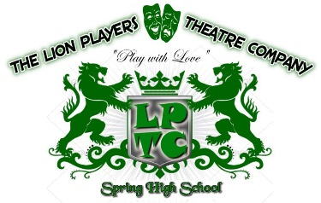

Here are the submaster assignments for those of you that do not want to program your light but would rather run the board manually.

Sub 1 = area 1
Sub 2 = area 2
Sub 3 = area 3
Sub 4 = area 4
Sub 5 = area 5
Sub 6 = area 6
Sub 7 = area 7
Sub 8 = area 8
Sub 9 = area 9
Sub 10 = area 10
Sub 11 = area 11
Sub 12 = area 12
Sub 13 = area 13
Sub 14 = area 14
Sub 15 = area 15
Sub 16 = blue wash
Sub 17 = red wash
Sub 18 = green wash
Sub 19 = white wash (downs and mid stage only)
Sub 20 = Full Stage area and Full Wash - Everything

